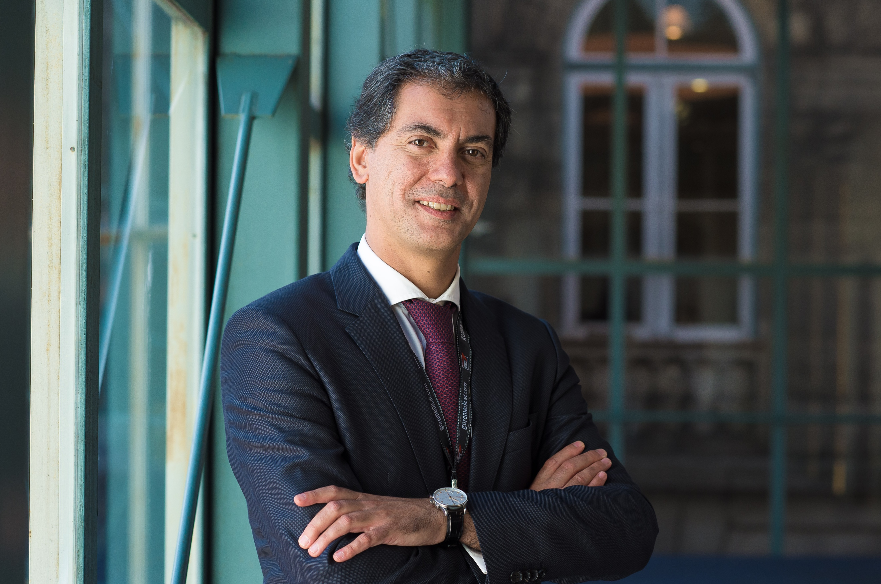

Armando Mansilha MD, PhD, FEBVS

Mother tongue: Portuguese
Other Languages: English, Spanish, French

PROFILE

CLINIC
- Senior Consultant of Angiology and Vascular Surgery of the University S. João Hospital
- Director of the Department of Angiology and Vascular Surgery of CUF Porto Hospital
- Coordinator of Angiology and Vascular Surgery of PortoClínica

ACADEMIC
- Professor of Vascular Surgery of the Faculty of Medicine of University of Porto
- PhD in 2005 with the doctoral thesis “Genetic polymorphisms and risk of deep venous thrombosis in young people”
- Aggregation in 2016 with the title “Carotid endarterectomy under local anesthesia”
- Curricular Unit Coordinator of CardioVascular Diseases, Vascular Surgery – clinical practice and Phlebology, Faculty of Medicine of University of Porto

SCIENTIFIC
- More than 300 publications in peer-review journals and books
- More than 950 citations
- More than 900 conferences, communications and round tables as speaker
- Coordination of 29 research projects and clinical trials
- Supervision of 30 PhD doctoral and masters theses in Medicine
- Organization of 90 scientific congresses, meetings and courses
- Editorial Board Member and Reviewer of 9 national and 26 international journals
- Coordinator of the national project “AAA screening”, promoted by the SPACV
- Coordinator of the national project “What do you know about your veins”, promoted by the SPACV
- Coordinator of the national awareness project “Healthy Veins”, promoted by the SPACV
- Coordinator of the Book “Recommendations on the diagnosis and treatment of the Chronic Venous Disease”, promoted by the SPACV

POSITIONS AND AWARDS

2000 Research Grant, International Society for CardioVascular Surgery
2000 Research Grant, European Society for Vascular Surgery
2001 Research Grant, European Society for Vascular Surgery
2002 FEBVS - Fellow of the European Board of Vascular Surgery, UEMS
2003 Examiner, UEMS Section and Board of Vascular Surgery
2005 Council Member, Union International de Phlébologie
2006 Executive Committee, College of Angiology and Vascular Surgery, Portuguese Medical Association
2009 Secretary General, UEMS Section and Board of Vascular Surgery
2009 Council Member, European Society for Vascular Surgery
2011 Section Editor, Reviews in Vascular Medicine
2013 Chairman, Porto Vascular Conference
2013 Council Member, Mediterranean League of Angiology and Vascular Surgery
2013 Honorary Member, The Vascular Society for Great Britain and Ireland
2014 Council Member, International Union of Angiology
2015 President of the LOC Annual Meeting, European Society for Vascular Surgery
2016 President, European Venous Forum
2017 Member, Moynihan Club
2017 Honorary Member, Societat Catalana d’Angiologia, Cirurgia Vascular I Endovascular
2018 Editor in Chief, International Angiology Journal
2018 President, Portuguese Society of Angiology and Vascular Surgery (SPACV)
2019 President, Portuguese Society of Phlebology
2019 UEMS Accreditation as European Rotating Centre of Phlebology
2019 Best International Scientific Publication, SPACV Award
2019 Best International Scientific Contribution, SPACV Award
2020 EVST Training Center

